**Objective:**

* Working with the analysis of combinational logic networks
* Knowing the implementation of networks using the two canonical forms.

**List of Equipment**

* Trainer Board
* 1* IC 4073 Triple AND gates
* 2* IC 4075 Triple OR gates
* 1* IC 7404 Hex Inverters (NOT gates)

**Theory:**

Minterm:

For a [boolean function](https://en.wikipedia.org/wiki/Boolean_function" \o "Boolean function) of n{\displaystyle n} variables x1 , … , xn {\displaystyle {x_{1},\dots ,x_{n}}}, a [product term](https://en.wikipedia.org/wiki/Product_term) in which each of the n{\displaystyle n} variables appears once (in either its complemented or uncomplemented form) is called a minterm. Thus, a minterm is a logical expression of n variables that employs only the complement operator and the conjunction operator.

Maxterm:

For a [boolean function](https://en.wikipedia.org/wiki/Boolean_function" \o "Boolean function) of n{\displaystyle n} variables x1 , … , xn {\displaystyle {x_{1},\dots ,x_{n}}}, a sum term in which each of the {\displaystyle n}n variables appears once (in either its complemented or uncomplemented form) is called a maxterm. Thus, a maxterm is a logical expression of n variables that employs only the complement operator and the disjunction operator. Maxterms are a dual of the minterm idea (i.e., exhibiting a complementary symmetry in all respects). Instead of using ANDs and complements, we use ORs and complements and proceed similarly.

Analysis of combinational logic design:

Combinatorial circuits comprise logic gates whose outputs at any time are determined by combining the values of the applied inputs using logic operations.  If there are n input variables.

The design procedure for combinational logic circuits starts with the problem specification and comprises the following steps:

1. Determine required number of inputs and outputs from the specifications.
2. Derive the truth table for each of the outputs based on their relationships to the input.
3. Simplify the boolean expression for each output. Use Karnaugh Maps or Boolean algebra.
4. Draw a logic diagram that represents the simplified Boolean expression. Verify the design by analysing or simulating the circuit.

Canonical forms:

The technique that is used to represent the mathematical entities or matrix in its standard form (or mathematical expression) is termed as canonical form. The term canonicalization is also known as standardization or normalization with respect to the equivalence relation.

**Circuit Diagram:**

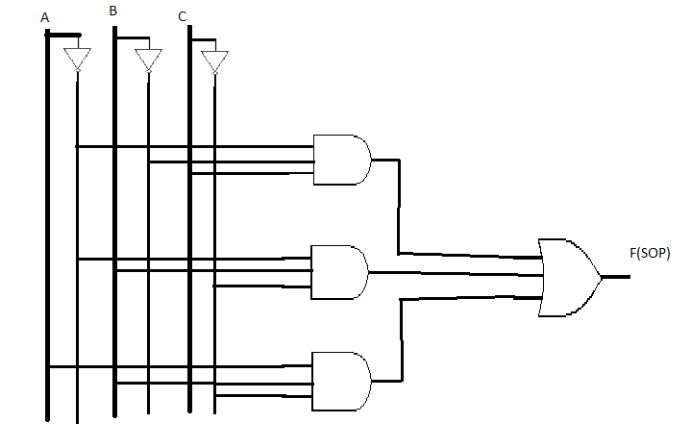

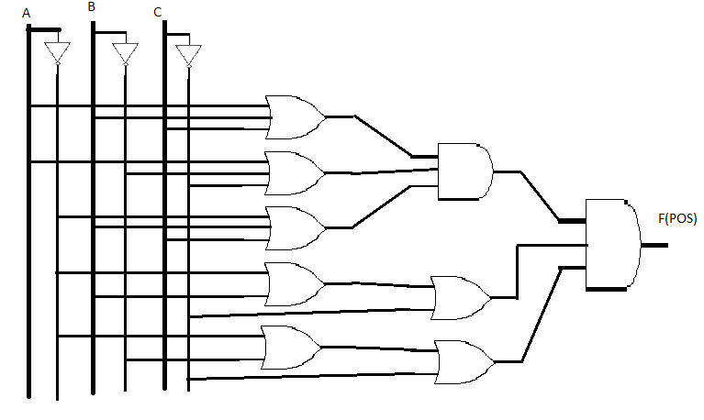

**Data/Truth table:**

|  |  |  |  |  |  |  |
| --- | --- | --- | --- | --- | --- | --- |
| INPUT  Reference | INPUT | | | F | Min term | Max term |
| A | B | C |
| 0 | 0 | 0 | 0 | 0 |  | A + B + C |
| 1 | 0 | 0 | 1 | 1 | $$\overline{A }\overline{B}C$$ |  |
| 2 | 0 | 1 | 0 | 1 | $$\overline{A }B\overline{C }$$ |  |
| 3 | 0 | 1 | 1 | 0 |  | $$A+\overline{B }+\overline{C }$$ |
| 4 | 1 | 0 | 0 | 0 |  | $$\overline{A }+B+C$$ |
| 5 | 1 | 0 | 1 | 0 |  | $$\overline{A }+B+\overline{C }$$ |
| 6 | 1 | 1 | 0 | 1 | A B $\overline{C }$ |  |
| 7 | 1 | 1 | 1 | 0 |  |  |

|  |  |  |
| --- | --- | --- |
|  | Shorthand Notation | Function |
| 1st Canonical form | F = Ʃ(1,2,6) | F = $\overline{A }\overline{B}C$ + $\overline{A }B\overline{C }$ + A B $\overline{C }$ |
| 2nd Canonical form | F = **Π(0,3,4,5,7)** | F = (A + B + C)($A+\overline{B }+\overline{C }$)($\overline{A }+B+C$)($\overline{A }+B+C$)  ($\overline{A }+\overline{B}+\overline{C }$) |

**Discussion:**

In this experiment we got to know about two canonical forms and how they work. We also come to know that two different circuit can give the same result if they are arranged properly. Using both minterm and maxterm we can create the same truth table.

We had only 2 ICs with three input OR gate and 1 IC with two input OR gate. For minterm we didn’t face any problem as there required only 3 three input AND gate. One 4073 IC have 3 three input AND gates. So that was not that much of problem. But in maxterm we had to use both three input OR gate and two input OR gate. As there was lack of three input or gate.

While using two input OR gate we had to at first connect two channels with a OR gate and then connected the output to another OR gate’s input and the other input of that gate was the third channel. By using this method we had to get the last two maxterms.

Then we connected first three OR gate output to a three input AND gate. After that the output of that gate connected to another three input AND gate along with the outputs of the last two maxterms.

Wiring the circuit in maxterm was quite challenging because we needed to connect a lot of gates. So we needed almost 45 wares to connect the whole circuit. All our equipment was perfectly working. So we did it on the first try. So we did not have to face that much of trouble in this experiment.

